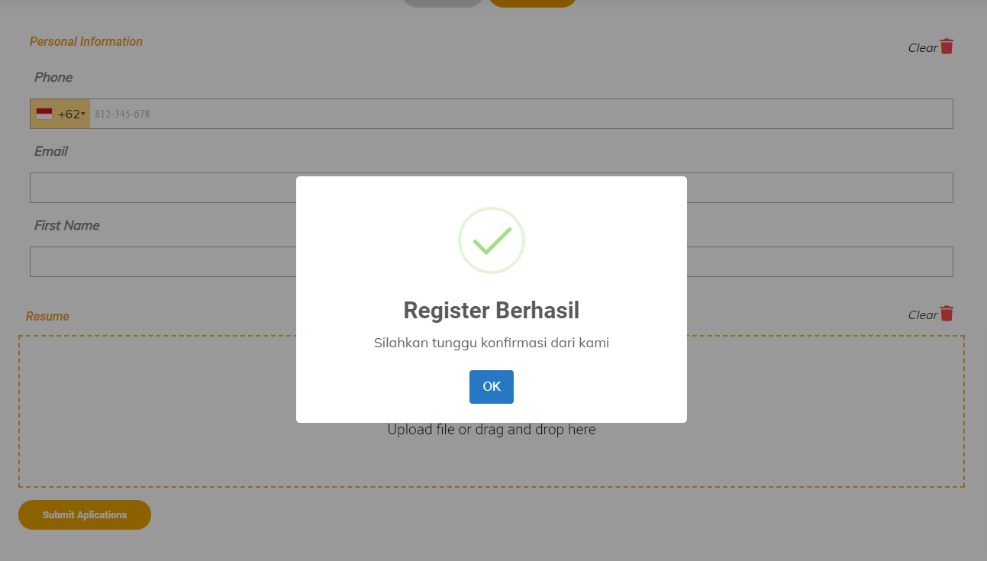

1. Baru upload File aja sudah bisa Submit application, harusnya semua field sudah terisi.

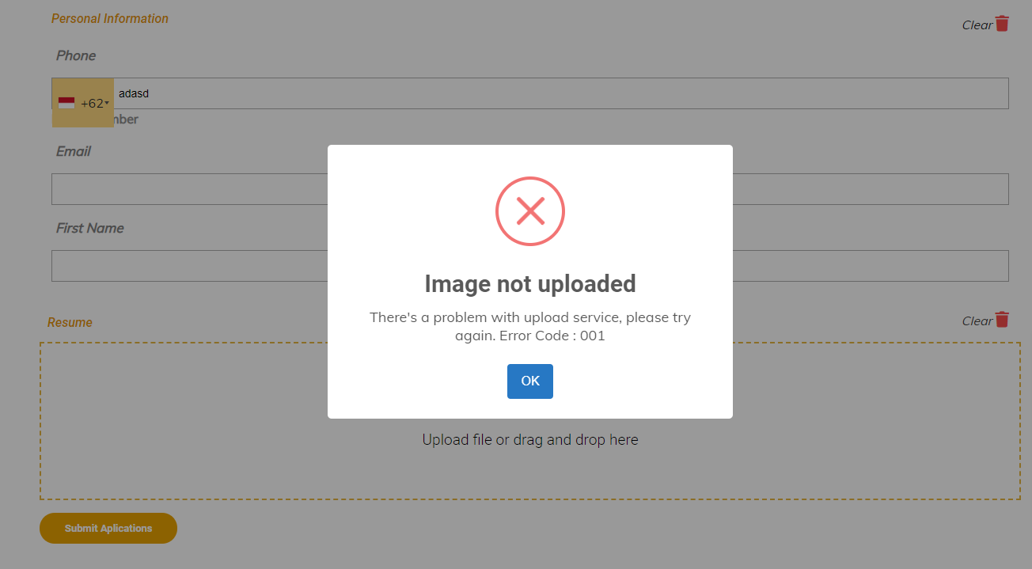

1. Error ketika blm upload File ganti

”file not uploaded

Please upload your file”

1. Semua field masihbelum required kecuali upload file.

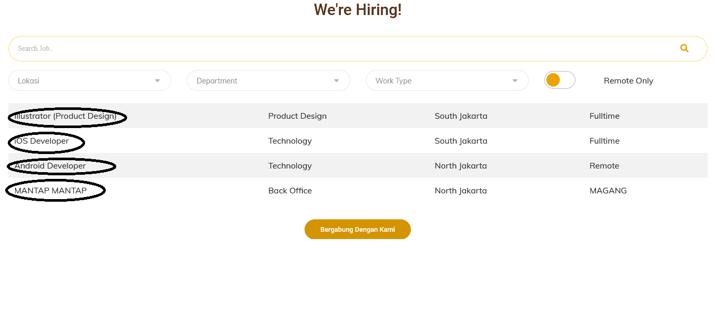

1. Dibagian yang buletin dijadikan bisa diklik langsung ke Halaman Job Detailnya contoh Android Dev diklik ke https://dev-monika-ps.cac-office.com/detail/TKAR003